

Accern

Assignment

Swatantra Kumar Mishra | Front-End-Developer | 20-01-2017

Email - [swatantramishra1@gmail.com](mailto:swatantramishra1@gmail.com)

Mobile No - 9538406805

# Cover Parts

I have cover all pages like Dashboard, Resource, Contact and Company with login URL

## langauges & Tools

Used following script languages and tools for this web app

* AngularJS, Bootstrap, CSS3, JavaScript.
* IDE for this Web app used Visual Studio 2015
* Used online tool for minified CSS and JS to make it lighter weight.

## NEw THINGS (DESign parts)

Used following things to make good according my perception

* Used new collapsible panel 
* **Reson** – It looks good easy to, understand user that on click, it will expand
* Used new button 
* **Reson** – It does not have on hover revert property because of it looks more promising than earlier.
* Contact Page (Parts)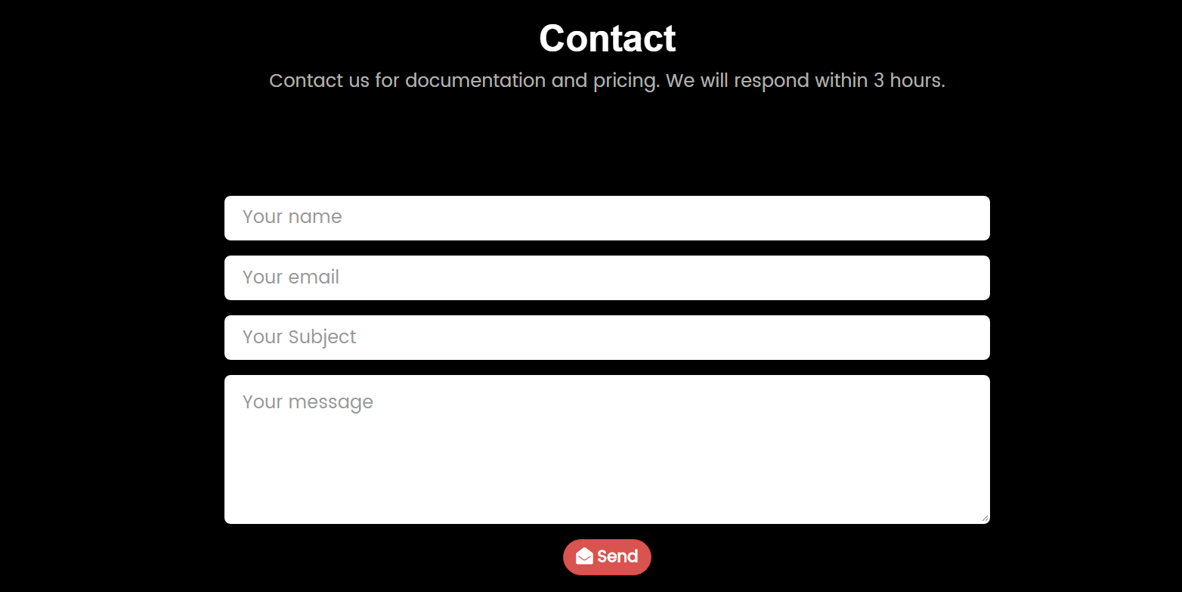
* **Reson** – All page have designed with bootstrap design, this part looks like material so I thought will make like bootstrap and on focus it will make a border of Master color so it will give some different look.
* Resource page “API RESOURCES” 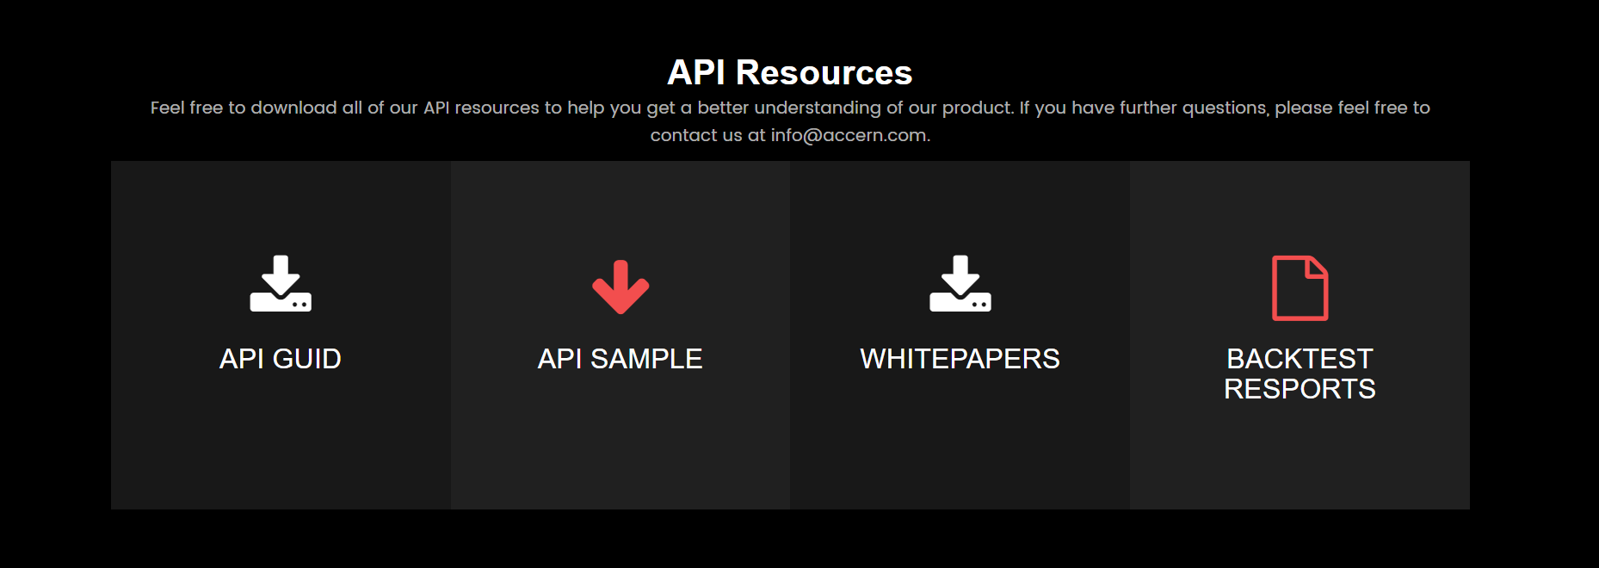
* **Reson** – I have made this because it has icon which will make it understandable to end user and alternate color as master color makes it eye catchable.
* Header with Icon
* **Reson** – With icon header make sense so here also thought to make it like this.
* Onclick contact Email “[info@accern.com](mailto:info@accern.com)” open Emailer to send email.

## Bonus Points

Used following things

* Zendesk Chat API

# Uncover Parts (Time Constraint)

Following are uncover parts which is not covered due to time constraint.

* Company page - Heading “**Our Technical Process** Of Discovering Early News” WIP for Animation of bubbles will update once it done, not achieved because of it was taking time but I am trying to complete it and then send it with code.
* Company page - Heading “40” number flickering.
* Mobile size main image is not in center, I have used background image so that I can get over lay easily but when I am using “ position: center” it makes image appear above. I am still working on it

# Page Speed Improved

* Used AngularJS to make it easy to maintainable.
* Used AngularJS router to route page without any flickering –

<http://accern.com> > Open website > Go to any page like “Contact” > reload all pages so that it download all css , js and images from server to client, which makes it slow ,To avoid this used AngularJS UI-Routing : Once you open page which filed are going to static , I am caching on the client side so that after again loading should not need to download again from the server.

* Used css for transition in your website it happening through js and lots of css.
* Used minified file on server while deploying it makes it faster and reliable. open <https://accern.herokuapp.com> > it shows stats
* 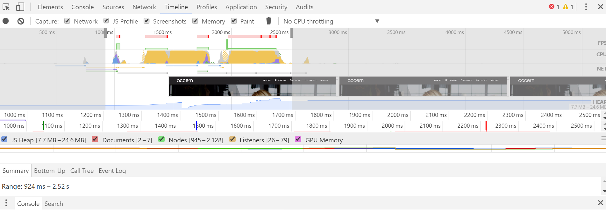
* <http://accern.com> > after one time open again reload 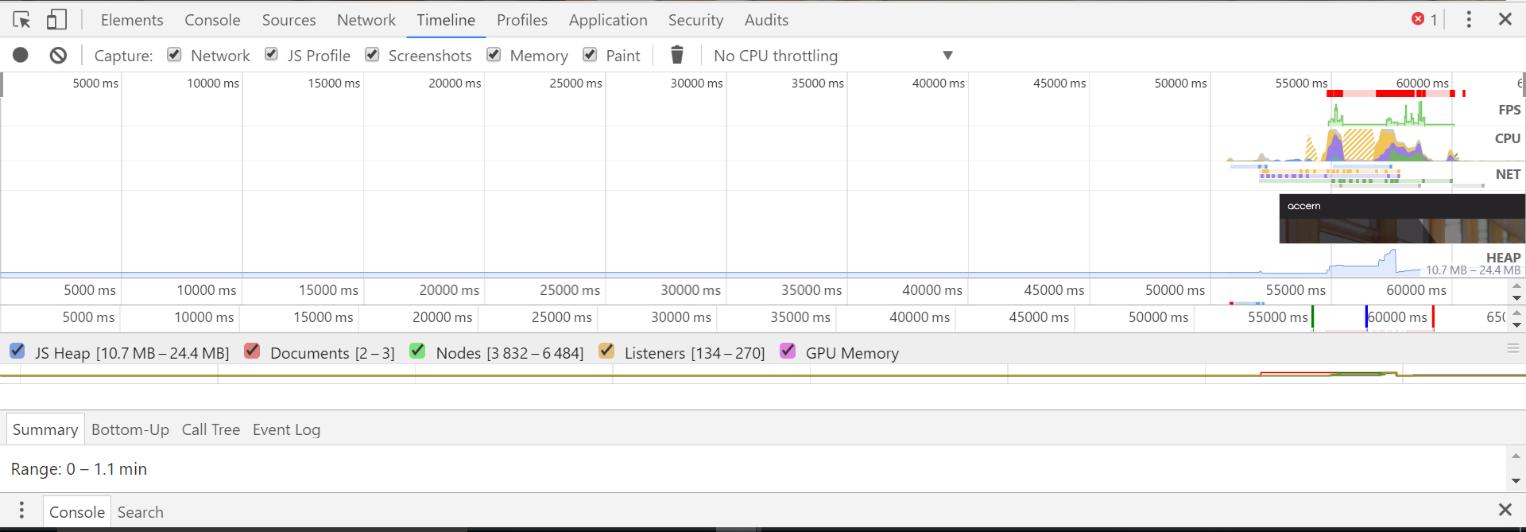
* Image takes too much time to load so I cached it to reuse meanwhile.

# Needs to improve

Following parts are needed to cover while we will make “http://accern.com”.

* We can use less size images which will make page faster.
* Use of CDN (Content delivery network) can play major role in page speed.
* In <http://accern.com> - A lot many in-line CSS and JS code has been used which needs to be taken care of writing them in a separate file and using its minified file’s reference.

# Conclusion

In summary, thanks for this opportunity. Got to learn more about page optimization and building website in quick time.